

# INTRODUCTION

# Overview

# This is an application which we can used for travel planning , first the user has to create an account and then the user needs to login. User can click the places given there and choose the places.

* 1. Purpose

This project is used to make travelling easier to the world. It demonstrates how to create a simple travel app using the Compose libraries. It also features a personalized feed of recommended accommodations based on the locations.

1. **PROBLEM DEFINITION & DESIGN THINKING**
   1. Empathy Map

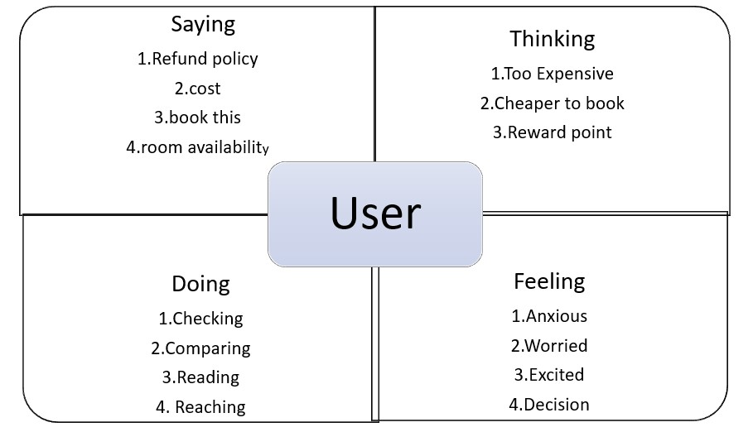

* 1. Ideation & Brainstorming Map

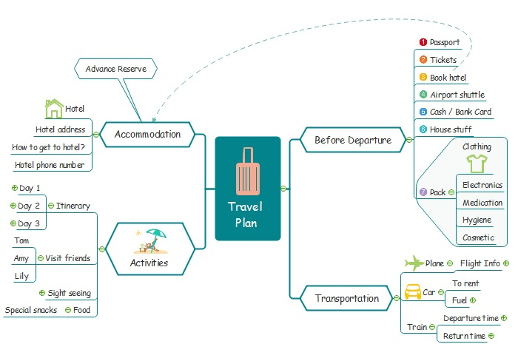

# RESULT

# Data Model

|  |  |
| --- | --- |
| **Object name** | **Fields in the Object** |
| Sign up | |  |  | | --- | --- | | Field label | Data type | | Username | String | | Password | String | | Email | String | |
| Log in | |  |  | | --- | --- | | Field label | Data type | | Username | String | | Password | String | |

# 

# The screenshots of your project activity along with the description.

# 

Sign Up :

It is a page where user have to register for creating new account for them , then only they can log in with that details

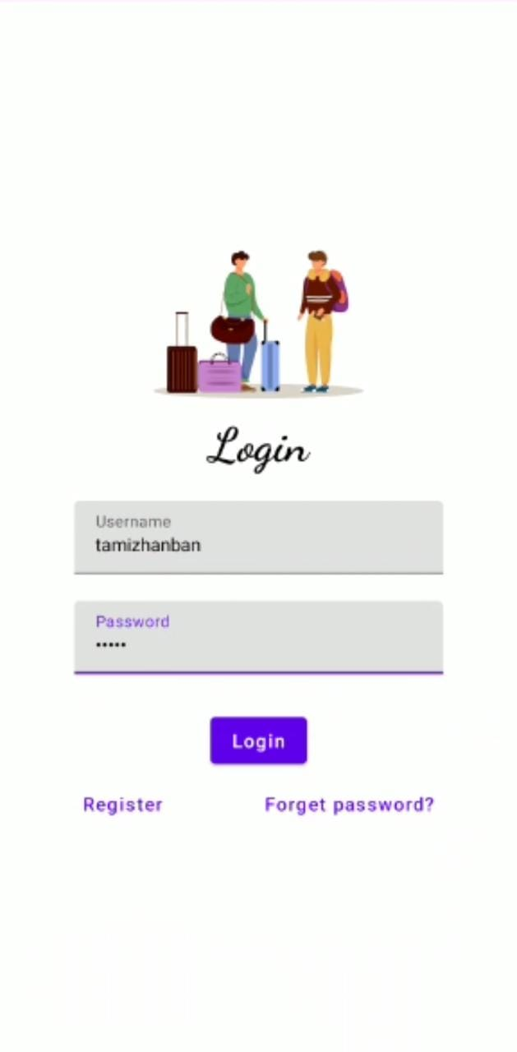

Login :

The user should enter a correct details to login

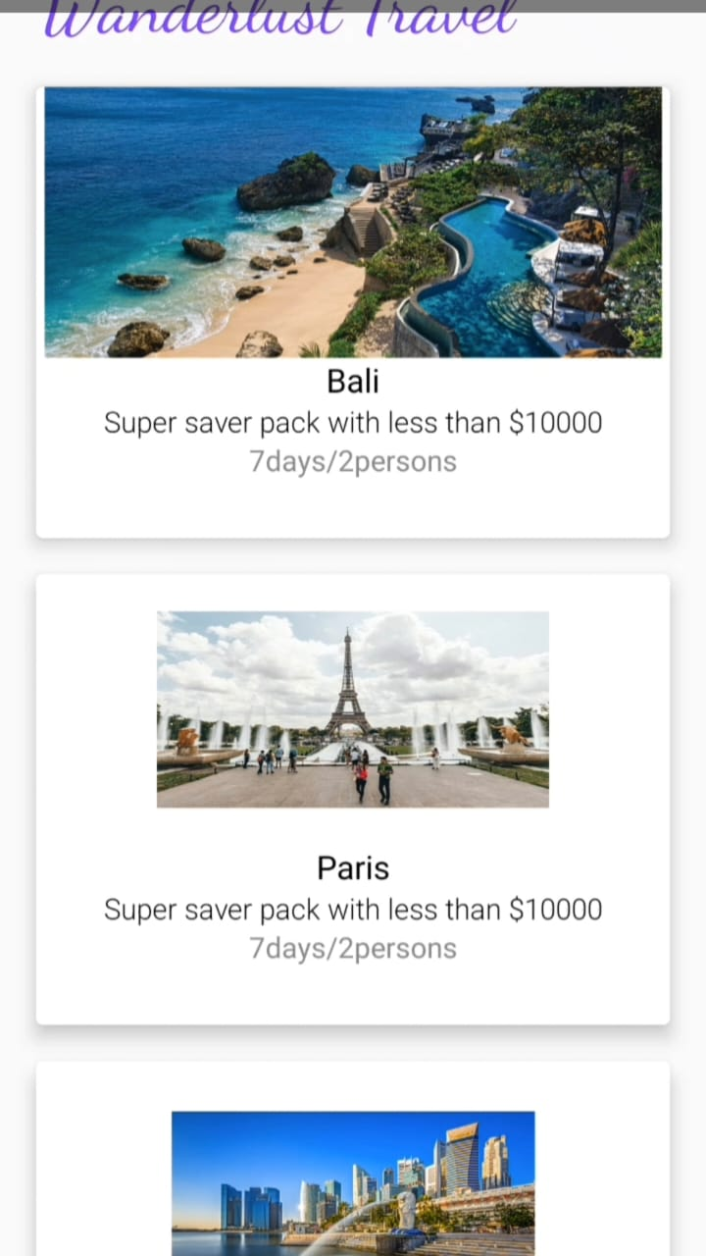

In this page we can see the places and some things about it

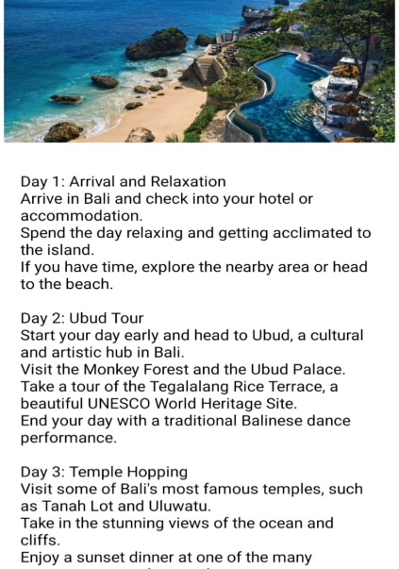

In this page we can see the brief explanation about the places and amount packages

# GOOGLE DEVELOPER PROFILE PUBLIC URL

**Team lead** – [https://g.dev/Ajas](https://g.dev/Ajas%20)

# 

# Team member 1 -

# <https://g.dev/Tamizha>

# Team member 2 –[https://g.dev/Sivabalan_2510](https://g.dev/Sivabalan_2510%20)

# 

# Team member 3 –

# <https://g.dev/Jaison1203>

1. **ADVANTAGES & DISADVANTAGE**

# Advantages :

# Personalized travel recommendations: Wanderlust can provide personalized travel recommendations based on the user's interests, budget, and travel history, making it easier for them to plan their trip.

# Time-saving: The app can save users time by providing them with information on flights, accommodations, and attractions, all in one place.

# Improved travel experience: With the app, users can create detailed itineraries, track their expenses, and store important travel documents, which can help improve their overall travel experience.

# Social sharing: Wanderlust allows users to share their travel experiences with friends and family on social media, helping them keep in touch and inspiring others to travel.

# Disadvantages :

# Data privacy concerns: With the amount of personal information involved in travel planning and tracking, users may have concerns about the security of their data.

# Dependence on technology: Users may become overly reliant on the app, which could limit their ability to explore new places and have unexpected experiences.

# Technical issues: Any technical issues with the app, such as bugs or server downtime, could cause inconvenience and frustration for users.

# Limited coverage: The app may not cover all destinations and attractions, limiting its usefulness for users traveling to less popular or remote locations.

# 

# APPLICATIONS

# The app can be used by tourism boards and destination marketers to promote their destinations and attractions to potential travelers

# 

**7.** **CONCLUSION**

# A Personalized Travel Planning and Tracking App offers numerous benefits for travelers who are looking for a more personalized and streamlined travel planning experience. With the app's ability to provide customized travel recommendations, detailed itineraries, and expense tracking, users can enjoy a more efficient and stress-free trip.

1. **FUTURE SCOPE**

. By integrating Artificial Intelligence the app can provide more accurate and relevant recommendations, personalize travel experiences even further, and improve the overall user experience. By integrating Augmented Reality ,the app can provide users with more interactive and informative travel recommendations, allowing them to explore destinations in a more engaging way.